**Master Functional Document**

|  |  |
| --- | --- |
| **Application** | NGERP - Centra |
| **Service Bundle** | Master Management |
| **Service Request** | Tenant |

**Description :**

Tenant is used to monitor all the functions in the NGERP application.

**Workflow Process :**

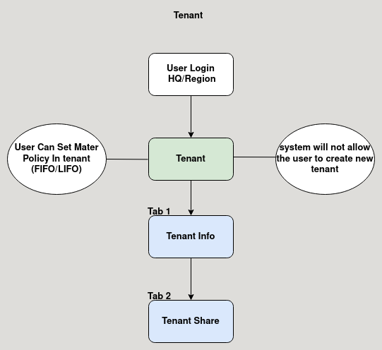

**Business Rules :**

* User can login to HQ or Region to view tenant.
* User cannot able to create new tenant.
* User can set material policy in tenant master (FIFO/ LIFO).
* Tenant info tab shows the tenant information.